**EVENT NAME – IG REELS**

|  |  |  |
| --- | --- | --- |
| **LEVEL** | **MIDDLE** | **SENIORS** |
| **STD** | **VI to VIII Std** | **IX to X Std** |
| **THEME** | **Heritage in a Minute:** Showcase a local heritage site or tradition in a 60-second Reel  Or  **Cultural Heritage Dance Challenge:** Create a dance challenge showcasing traditional dances.  Or  **Heritage Storytelling:** Share stories about local heritage sites or traditions. | **Heritage and Environment:** Highlight the connection between cultural heritage and environmental conservation  Or  **Cultural Heritage and Identity:** Explore how cultural heritage shape’s personal identity  Or  **Innovative Solutions for Sustainable Heritage**: Share innovative solutions for preserving heritage |
|  | **SENIOR SECONDARY** |  |
|  | **STD XI TO XII** |  |
|  | **Sustainable Heritage and Climate Change:** Highlight the impact of climate change on cultural heritage.  Or  **Heritage Conservation and Community Engagement:** Showcase community-led heritage conservation initiatives.  Or  **Heritage and Technology:** Explore the use of technology in preserving cultural heritage. |  |
| **MODE OF EVENT** | Individual and recorded | |
| **DURATION** | 60 sec to 90 sec | |
| **LOCATION** | Alliance Francaise Auditorium, Suffrein Street, Heritage Quarter, Pondicherry | |
| **DATE** | 17 Feb 2025 (Monday) | |
| **NUMBER OF ENTRIES PER SCHOOL** | 3 entries per category in each school | |
| **LAST DATE FOR REGISTRATION** | **15 Feb 2025 (Sat)** | |

**POINTS TO BE NOTED**

**IG REELS**

Reels have recently become a medium for the youth to express their creativity and bring in finer trends on social media.

All you have to do is submit a 60 - 90 seconds long reel and get the chance to be featured on our Instagram page.

#### The best reel shall be chosen based on the creativity, and originality of the reel concept. The student has to post the Reel on his / her Instagram page with the hashtag **#pondicherryheritagefestival2025** (Note: The hashtag is case sensitive, make sure you post type the hashtag exactly as given)

#### **Guidelines**

* Plagiarised content will lead to disqualification although inspiration can be drawn from the existing trends online.
* Any derogatory remarks, name-calling, and/or regional slang towards any person or community should not be used.
* The video should not exceed one minute.
* Only one medium for the reels can be followed, the submissions can be in either English or Tamil
* Only one entry will be accepted by each participant, a second entry will lead to disqualification.
* The video should be made vertically and not horizontally.
* Use of offensive and inappropriate language or actions will lead to immediate disqualification.
* Individual, as well as group entries (not more than 3 people), are allowed.
* **In order to construct a reel, the participants must adhere to the Instagram Community Guidelines.**

The competition will run according to the following rules and procedures:

* The competitions will be held based on the themes that have been assigned to the students.
* In the competition, there will be two rounds, each of which will be outlined below:

Round 1 (Let’s Make Reels) consists of the creation of reels based on pre-determined themes. **Our professionals will analyse your reel, and students who meet the criteria will be qualified to move on to the next phase.**

* + **Attractive gifts would be given to the top 20% of the winners of Round 1.**
  + Round 2 (Share to Reach) consists of all the winners from Round 1 submitting the reels to their respective Instagram accounts. The contestants will then conduct a promotional effort to increase the reel’s popularity.

**GENERAL RULES AND REGULATIONS FOR IG REELS -**

1. Film has to be based on theme
2. **Duration – upto 90 sec**
3. Own content has to be there and there should not be clippings from other videos or professional movies should be there
4. Videos that portray or otherwise include inappropriate and / or offensive content, including provocative nudity, violence, human rights and / or environmental violation, and / or any other contents deemed contrary to the law, religious, political, cultural and moral traditions and practices of India, are strictly prohibited and will be immediately discarded
5. A participant who submits any such videos may be permanently banned from participating in any future contests.
6. Technicalities and content idea related questions may be asked by the Judge (s)
7. Vulgarity of any sort is strictly prohibited
8. Pondicherry Heritage Festival collective reserves the right to publish Reels in any online media without consulting the maker.
9. The decision of the Judging panel will be final.
10. We reserve the right to bar Entries for containing any infringing, threatening, misleading, false, abusive, harassing, defamatory, obscene, vulgar, inflammatory, scandalous, pornographic or profane content.
11. The theme has been shared and the delegate has to send the reels to the given email address - [phfschoolfinearts@gmail.com](mailto:phfschoolfinearts@gmail.com)

**JUDGING CRIETERIA**

|  |  |
| --- | --- |
| 1 | Originality |
| 2 | Creativity |
| 3 | Plot or story |
| 4 | Content |
|  | Theme depiction |
| 5 | Performance |
| 6 | Communication |
| 7 | Lip synchronisation |
| 8 | Technique |
| 9 | Entrance and exit |
|  | Number of hashtags in case of IG Reels |

**JUDGES OPINION IS FINAL AND BINDING**

**FINAL NOTE -**

|  |  |
| --- | --- |
| Duration of the recording | 60 secs to 90 secs maximum |
| The IG reels has to be sent to email ID | [phfschoolfinearts@gmail.com](mailto:phfschoolfinearts@gmail.com) |
| Google form registration (Compulsory) | <https://tinyurl.com/heritageschoolfinearts> |

## TIPS TO MAKE INSTAGRAM REELS

Instagram Reels are full-screen vertical videos that can be up to 90 seconds long. They come with many unique editing tools and an extensive library of audio tracks (featuring everything from trending songs to snippets of other users’ viral content). On top of sounds, Reels can include multiple video clips, filters, captions, interactive backgrounds, stickers, and more.

Reels are different from Instagram Stories. Unlike Stories, they don’t disappear after 24 hours. Once you post a Reel, it’s available on Instagram until you delete it.

## How to make a Reel on Instagram in 5 steps

If you’re familiar with Instagram and/or TikTok, you’ll find making Reels quite easy.

Are you a visual learner? Check out this video and learn how to make an Instagram Reel in under 7 minutes:

Otherwise, follow these simple step-by-step instructions.

### Step 1: Tap the plus icon at the top of the page and select **Reel**

To access Reels, simply open the Instagram app and head to your profile page. Click the plus sign button on the top right of the screen and select **Reel**.

You can also access the Reels editor by swiping left to the Instagram camera and selecting **Reel** from the bottom options.

### Step 2: Record or upload your video clip

Instagram Reels gives you two options to create a Reel:

1. Press and hold the record button to capture footage.
2. Upload video footage from your camera roll.

Reels can be recorded in a series of clips (one at a time), or all at once.

If you set a timer early on, there’s a countdown before the hands-free recording starts.

During the recording, you can tap the record button to end a clip, and then tap it again to start a new clip.

Then, the **Align** button will appear, allowing you to line up objects from the previous clip before recording your next. This allows you to create seamless transitions for moments like changing outfits, adding new music, or adding new friends to your Reel.

[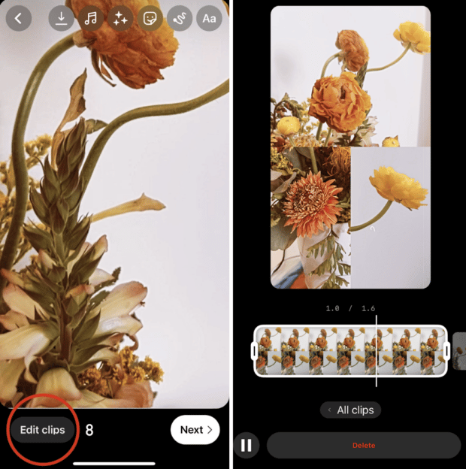](https://blog.hootsuite.com/wp-content/uploads/2022/08/word-image-8.png)

If you want to watch, trim, or delete the previous clip you recorded, you can tap E**dit Clips**. Check out our [Instagram Reels tutorial for more in-depth editing tips](https://blog.hootsuite.com/instagram-reels-tutorial/).

### Step 3: Edit your Reel

Once you’re done with recording, you can add stickers, drawings, and text to edit your Reel using the icons on the top of the editor.

The Reels editor features built-in creative tools so you can do all your editing from one interface.

[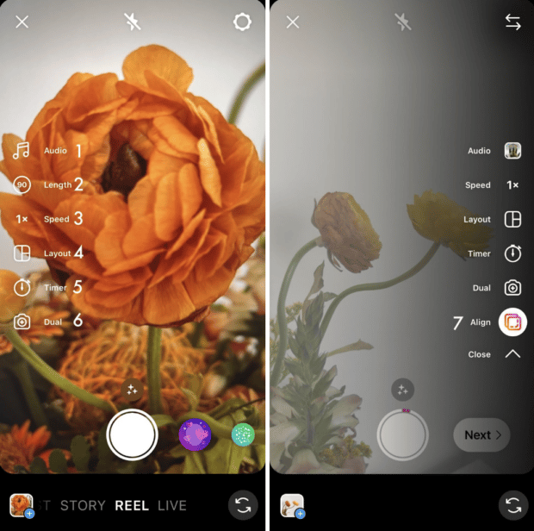](https://blog.hootsuite.com/wp-content/uploads/2022/08/word-image-9.png)

Here’s what each feature does:

1. **Audio** (1) lets you select audio from the Instagram music library or import it from your device and add it to your video. You can even choose to add your favorite part only.
2. **Length** (2) lets you change the length of your video. You can choose to make your video 15, 30, 60, or 90 seconds.
3. **Speed** (3) lets you change the speed of your video. Slow it down by choosing .3x or .5x or speed it up by choosing 2x, 3x, or 4x.
4. **Layout** (4) lets you adjust the layout and add more than one recording to the frame.
5. **Timer** (5) lets you set a timer that will go off before you start recording and set a time limit for the next clip. This is useful if you want to record hands-free.
6. **Dual** (6) lets you record videos using your front and rear cameras at the same time.
7. **Align** (7) appears after you record your first clip. It allows you to line up objects from the previous clip.

After you’ve aligned your clips, you can tap the **music note icon** to add trending sounds or music, or record a voiceover.

### [Adding stickers to an Instagram Reel and adjusting audio levels](https://blog.hootsuite.com/wp-content/uploads/2022/08/word-image-10.png)

You can also tap the **download** **icon** to download Instagram Reels to your device to view or edit later.

### Step 4: Adjust your Reel’s settings

When you’re ready, tap Next in the bottom right corner of your screen. You will be able to:

* Edit your Reel cover. You can choose a frame from the video or add an image from your camera roll.
* Add a caption.
* Tag people in your Reel.
* Add a location.
* Enable Facebook recommendations. If you select this option, your Reel will be surfaced to Facebook users who are likely to enjoy your content (according to Meta’s algorithms). You don’t need a Facebook account to use this feature.
* Rename your audio. If you add your own audio (e.g. a voice recording) to your Reel, you can give it a name that will show up in other users’ Reels if they decide to use the sound.
* Enable or disable automatically generated captions.
* Decide whether you want your Reel to be posted to your Instagram Feed (and not just the Reels tab on your account).

[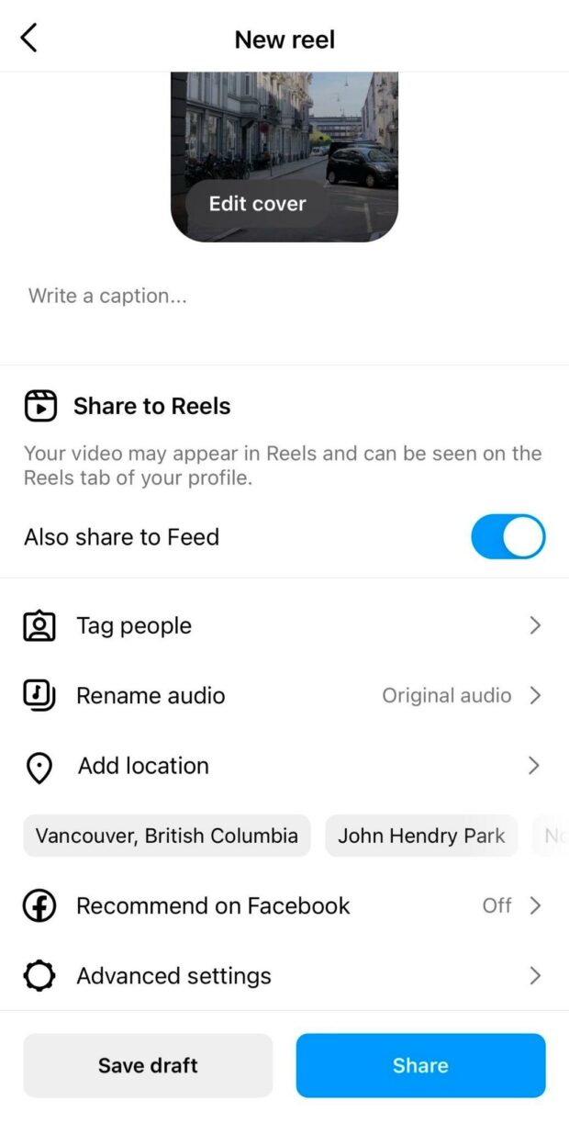](https://blog.hootsuite.com/wp-content/uploads/2022/08/word-image-35.jpeg)

### Step 5: Post your Reel

Once you adjust your settings, tap the **Share** button at the bottom of the screen.

Congrats! You’ve posted your first Reel. Now, let’s move on to some tactics that will help you make this format work for your brand.

***Optional: Schedule your Reel***

You’ve got your Reel ready to go, but maybe 11:30 pm on a Tuesday isn’t the best time to get maximum exposure. You might want to consider scheduling your Reel to post at a more ideal time.

Until recently, this feature was only available via Meta’s Creator Studio, or with a third-party tool like, you guessed it, [Hootsuite](https://www.hootsuite.com/instagram)!

In-app Reel scheduling is coming to both business and creator accounts, with Meta confirming that they “are testing the ability to schedule content with a percentage of our global community.”

While only available to lucky Android users at the moment (check your App, you might have it already!) the scheduling feature is expected to be available to everyone very soon.