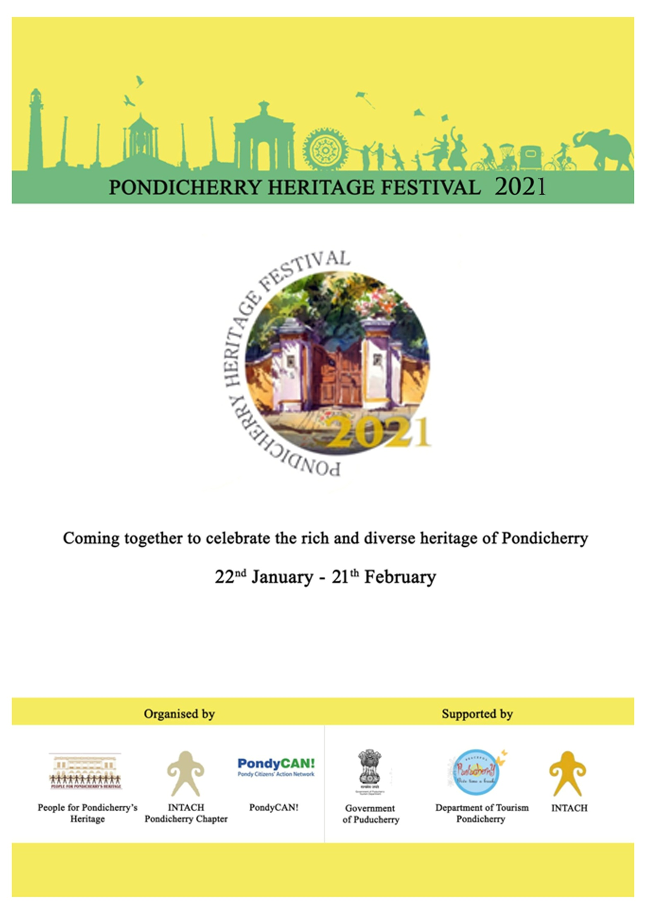

2020

**Pondicherry Heritage Festival 2021**

**Concept of Pondicherry Heritage Festival:**

Popular destinations across the world such as New York, Berlin, Paris and Sydney continue to attract a wide audience from all spheres of life and are melting pots for cultural exchanges. Pondicherry also has this quality of bringing together a diverse population of tourists and travellers looking for something to coax them into a new, exciting, passionate and yet peaceful lifestyle and environment. There is an unseen force behind how Pondicherry invites people of all cultures and yet retains its own, which expands beyond the exotic charm of its beautiful architectural heritage and sandy beaches.

Magical yet ordinary to the casual eye, the city harbours a deeper meaning and connection to the intangible realms of beauty, wisdom, tranquillity and harmony. This has led Pondicherry to become a universal platform for positive inner change and has inspired an inclusive, collective and inspiring evolution towards a future, long foreseen by the sages of yore. The marriage of spirituality and material research is a trademark of Pondicherry’s excellence and uniqueness. On November 29th, 2014, the collapse of the Mairie building (Town hall) of Pondicherry, which was built in 1870 to accommodate the offices for the mayor of Pondicherry, led to the realization that the need to conserve and celebrate the heritage of Pondicherry is immense.

A group thus emerged from the civil society called “People for Pondicherry’s heritage” (PPH)and conceived the idea of the Pondicherry heritage festival, first of which was held in 2015 and became an annual event. The Pondicherry heritage festival is being organised by People for Pondicherry’s heritage (PPH), INTACH Pondicherry and PondyCAN.

**The main objectives of Pondicherry’s heritage festival are:**

1. To create and strengthen this distinct identity of belonging and being Pondicherrian for all its residents,
2. To show its unique character in all its diversity to visitors who come from all over the country and the world attracted by the idea of “Pondicherry”,
3. To create a platform for experts, historians and old residents to meet and discuss what is special about Pondicherry and how we can preserve the same.

The charm and beauty of Pondicherry presents a unique challenge to the government and civil society interested in protecting and restoring its built heritage. Unlike the monuments and national parks under the purview of the Archaeological Survey of India, the architectural heritage of Pondicherry is a melange of private and government buildings. Pondicherry has two distinct parts namely, the French and Tamil quarters. The structures in the French quarter are a fusion of European classical style and local vernacular architecture and those in Tamil quarter are built in the vernacular style of Tamil Nadu. Both have influenced one another resulting in a harmonious blend of both the styles in many buildings.

Pondicherry’s unique architectural style is an inheritance of which we are but today’s custodians. It is our responsibility to preserve the essence of this built heritage for the future generations. It is with this vision that Pondicherry heritage festival sought to explore the various facets of the town’s culture, spiritual heritage, contributions to the world of art, literature, folk and classical music and dance, traditional and contemporary crafts and the work done by many organizations, institutions and individuals towards understanding and preserving the heritage of the town.

**Evolution of Pondicherry Heritage Festival:**

Now in its Sixth year, the Pondicherry Heritage Festival continues to celebrate the singular character of this extraordinary town and its environs. In the first year, 2015, attention was drawn to Pondicherry’s outstanding architectural legacy, its spiritual heritage and intangible heritage. The following year, 2016, the festival celebrated Pondicherry’s natural heritage, explored its heritage through the written word, visual arts and performing arts. In 2017, besides celebrating architectural, intangible and natural heritage, the festival focused on one of Pondicherry’s most ancient heritage, at Bahour. In 2018, the festival focused on the streetscapes of Pondicherry and expanded to explore another ancient heritage of Pondicherry, at Madagadiped, Thirubhuvanai and ThiruvandarKovil.In 2019, the emphasis of the festival was about Pondicherry’s splendid natural heritage, and specifically its wetlands and water bodies. This year it is all about The Talking streets of Pondicherry, Preserving our Cultural Heritage: Through the eyes of the Residence. The festival expanded in this year with several local organisations and all individuals actively involved & organising events, under the Pondicherry Heritage Festival banner and due to COVID -19 except few all events are conducting through Online. This overwhelming response made the heritage festival a four weeks event from 22th January to 21th February 2021.

“**Coming together to celebrate Pondicherry’s rich & diverse heritage**”

The success of the Pondicherry Heritage Festival is due to the active participation of our Festival partners and new participants.

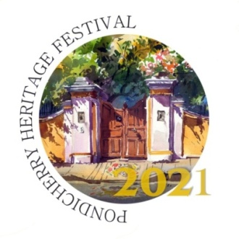

**Pondicherry Heritage Festival**

**22nd January to 21st February 2021**

**Press Release**

In its seventh year, the Pondicherry Heritage Festival (PHF) continues to celebrate the character of this extraordinary town and its environs. Originally conceived to draw attention to conserve Pondicherry’s outstanding architectural legacy, the festival has expanded its scope to embrace other aspects of heritage. It is the interplay of its diverse built environment, an idyllic seaside setting, its water bodies and ancient system tanks and ponds, a rich spiritual and intellectual history, and fascinating combination of indigenous and imported cultural practices that gives Pondicherry its distinctive flavour.

This year most of our activities will be virtual with a few exceptions. The theme this year is “Talking Streets of Pondicherry”. This is the splendid vernacular architecture of Pondicherry's Tamil built heritage. This built heritage is fading and many old Tamil houses are getting destroyed. This year the festival will draw attention to the acute need to preserve and safeguard Pondicherry’s Tamil precinct. As Pondicherry moves closer to obtaining status as a UNESCO world heritage city, the festival is delighted to host two important conversations. In the first, we will learn about Ahmadabad's UNESCO application from professor Mr.SaswatBandyopadhyay at CEPT and Ms.Shikha Jain, INTACH Convenor for Haryana. There will also be a Hands-on workshop about structural elements in the Heritage buildings during the festival. Pondicherry’s and Auroville’s creative entrepreneurs making the finest products and beautiful handicrafts came to the Crafts Bazaar for the Made in Pondy setting up stalls, bringing their products under one roof. This year we will bring the people to each of their outlets, including the delicious local food and Fair Trade outlets, identified by a special poster. This year too we have the “Creative expression by children” but all the events held online. 35 events for the school and 30 events for college students with the theme of Heritage to be imbibed into the young minds. An attractive event is planned for children less than 6 years to reach them and their parents. The theme of talking streets of Pondicherry through the eyes of its residents will be featured in another online event. Walks and cycle rides are planned taking in the idea of the talking streets outside the boulevard area. Since its start in 2015, the Pondicherry Heritage Festival has always been a volunteer effort, led by the People for Pondicherry’s Heritage, INTACH and PondyCAN, with very valuable support from the Government of Puducherry, Department of Tourism, the French Institute and the Alliance Francaise of Pondicherry as festival partners organising events or hosting them along with supportive local businesses.

The organizers hope the Heritage Festival continues to strengthen the respect of Pondicherian's for the traditions and treasures of this special seaside settlement, created by the confluence of cultures in a spectacularly beautiful setting. They believe that, by celebrating the heritage, it will become an important part of people’s lives and Pondicherry will retain its unique character.

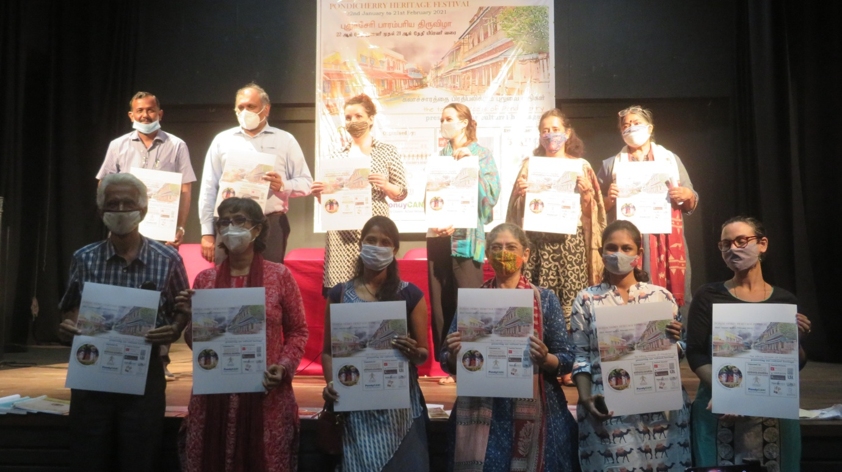 Organizers with Poster

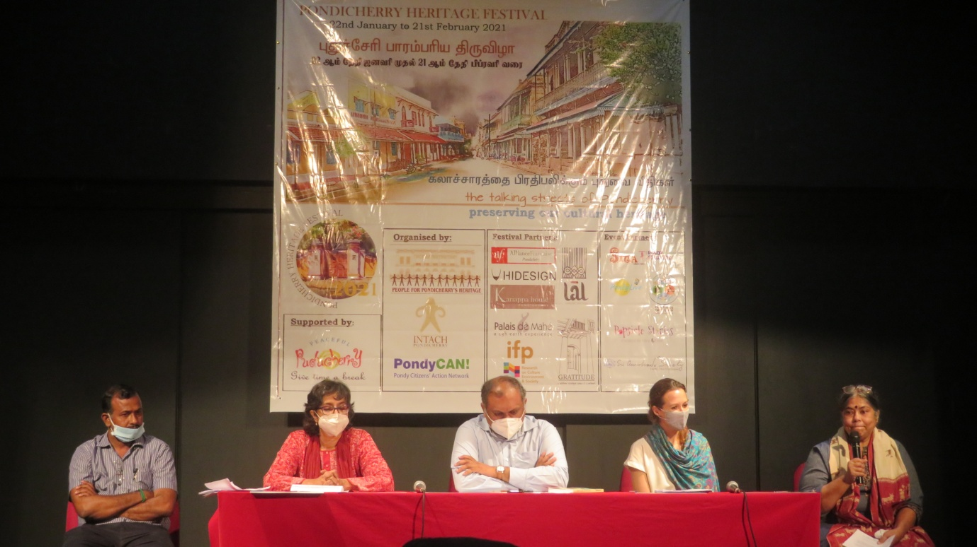Organizers while Interacting with Press

More information about the Pondicherry Heritage Festival and a schedule of events can be found at Website: [www.pondicherryheritagefestival.org](http://www.pondicherryheritagefestival.org) Facebook: https://www.facebook.com/PondicherryHeritageFestival/ Instagram: https://www.instagram.com/pondicherryheritage/

**Events of this year:**

1. **Workshop:**
   1. Workshop for civil engineer about structural elements of heritage building
   2. Natural dyes by Avani earth craft.
2. **Music:** 
   1. Carnatic vocal by Shobha Ramesh.
3. **Inauguration:**
   1. “Made in Pondy”.
   2. The Wetlands photo exhibition and prize distribution.
   3. The Wetlands Photography.
   4. Photo contest and exhibition.
   5. One school one pondy (OSOP).
4. **Discussion in ONLINE :** 
   1. Talk & discussion by Ari Gaultier and AnanyaKabir on the subject: The impact disappearing thinnai’s have on pondicherry’s cultural heritage.
   2. Road to UNESCO recognition an expert panel discussion.
   3. Talking streets of Pondy through the eyes of the residents.
5. **Academic competition in ONLINE :**
   1. Heritage Quiz for school and college students.
   2. Art activities for school and college students.
   3. Literary for school and college students.
   4. Cultural activities for school and college students.
6. **Dance in ONLINE:** 
   1. School and College students dance.
7. **Cycle tour: SITA Cultural Center: The talking walls, Pondy Street Art Cycle tour.**
8. **Photo walk: A themed urban exploration of the fishing villages of Kuruchikuppam - Vaithikuppam.**
9. **Heritage walk: Pondicherry’s Tamil Heritage walking tour with storyteller.**
10. **Heritage Preservation Award: To give the Guardian of our eritageHHeritage 2021 Award.**
    1. **Photo contest and Exhibition:**

On 29th of January, Inauguration of the Photo contest and Exhibition was held at INTACH Pondicherry in the topic of Memories of Life in and around our Thinnai.

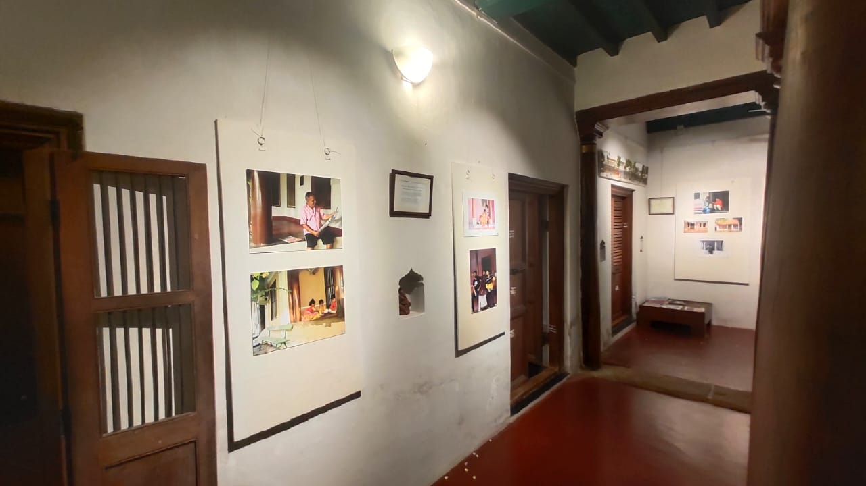

**Photo display**

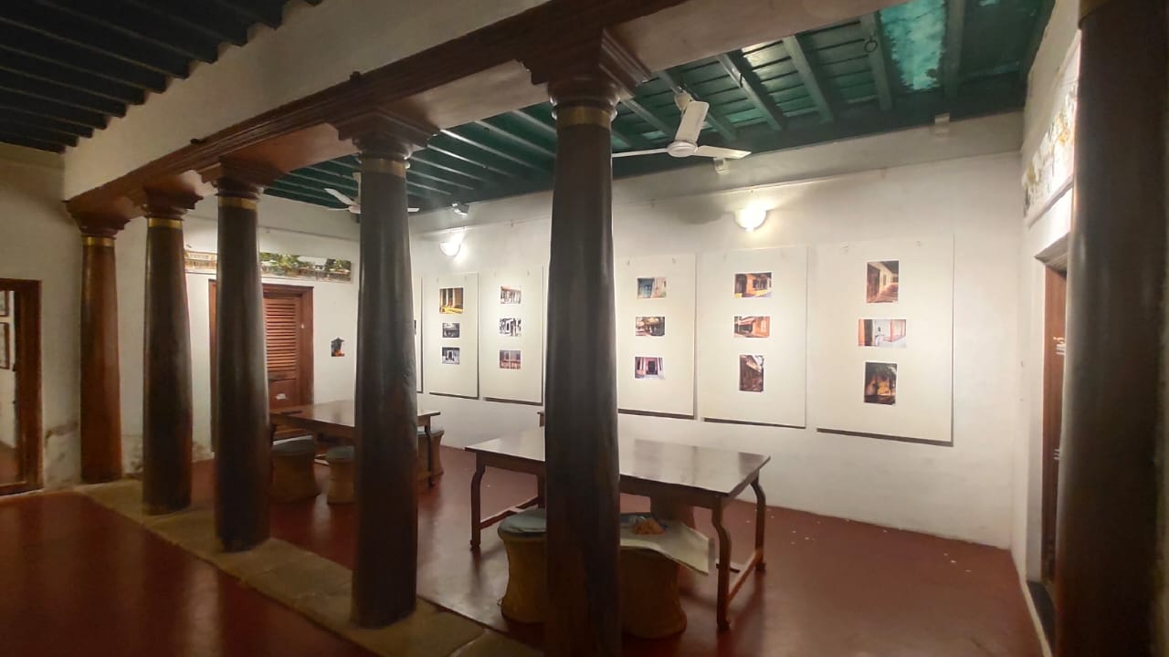

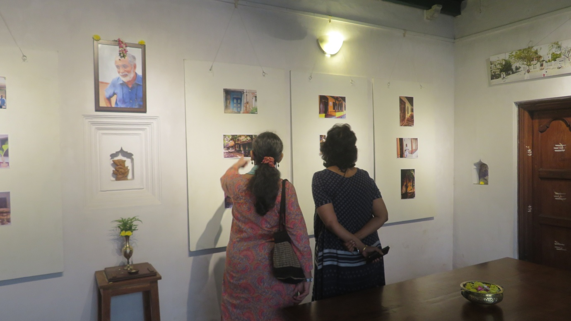

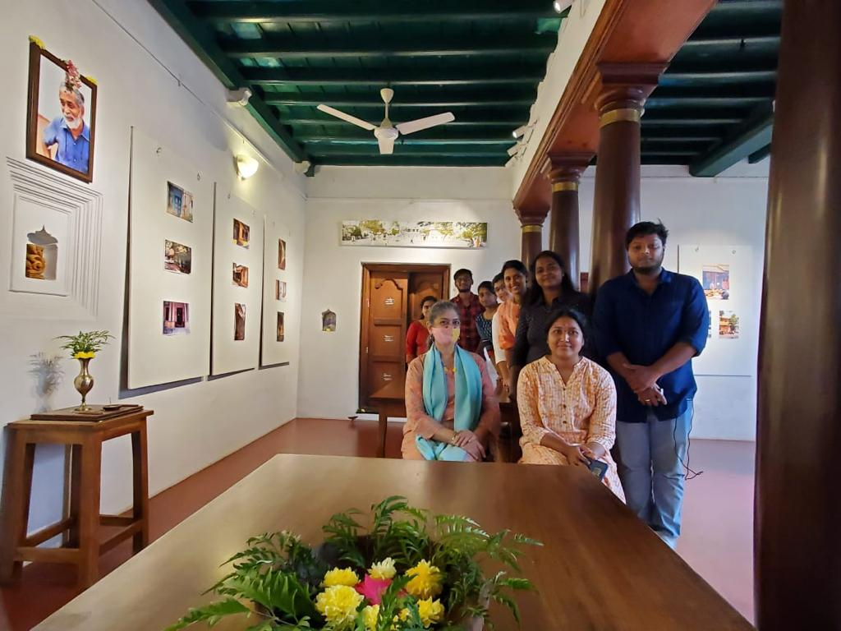

* 1. **One School One Pondy (OSOP):**

On 2nd of February, Inauguration of Water festival 2021 and organised by Alliance for good Governance AGG. Welcome address by Thiru Prabir K.Banerjee and Thiru C.H. Blamohanan. Water festival launched by Dr. Kiran Bedi, Honourable Lt. Governor of Puducherry. By continue Lt. Governor, Thriu P.T Rudra Goud, Director Department of school Education. Tmt.Purva Garg, Secretatry Fisheries & Tourism, District Collector. Thiru E. Vallavan, Secretary Local Administration & Labour. Thiru A. John Kumar, MLA Kamaraj Nagar Constituency are addressed in the Inauguration of Water festival 2021. And finally Vote of Thanks by Thiru N.Dinakar, State Project Director, Samagra Shiksha.

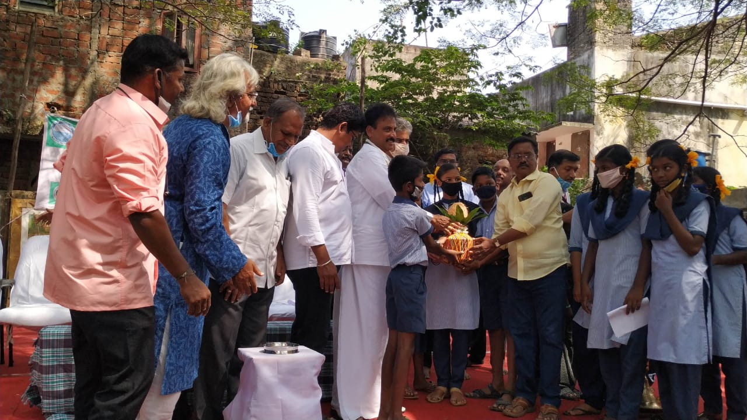

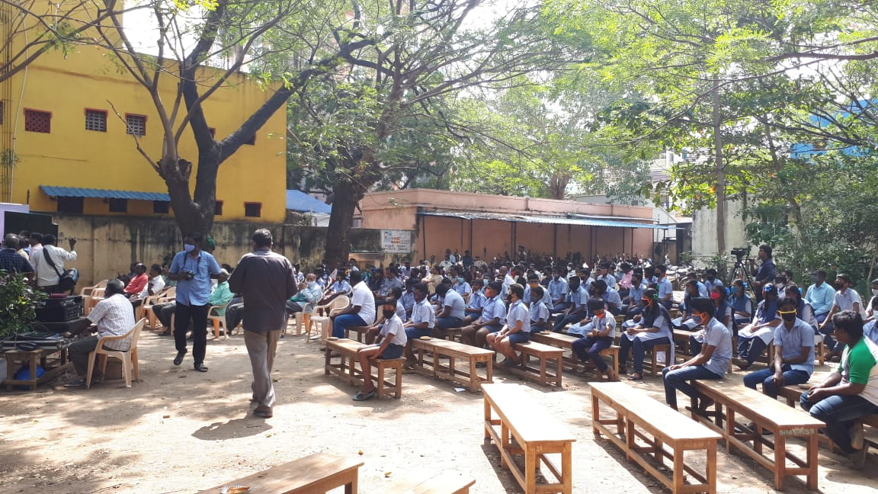

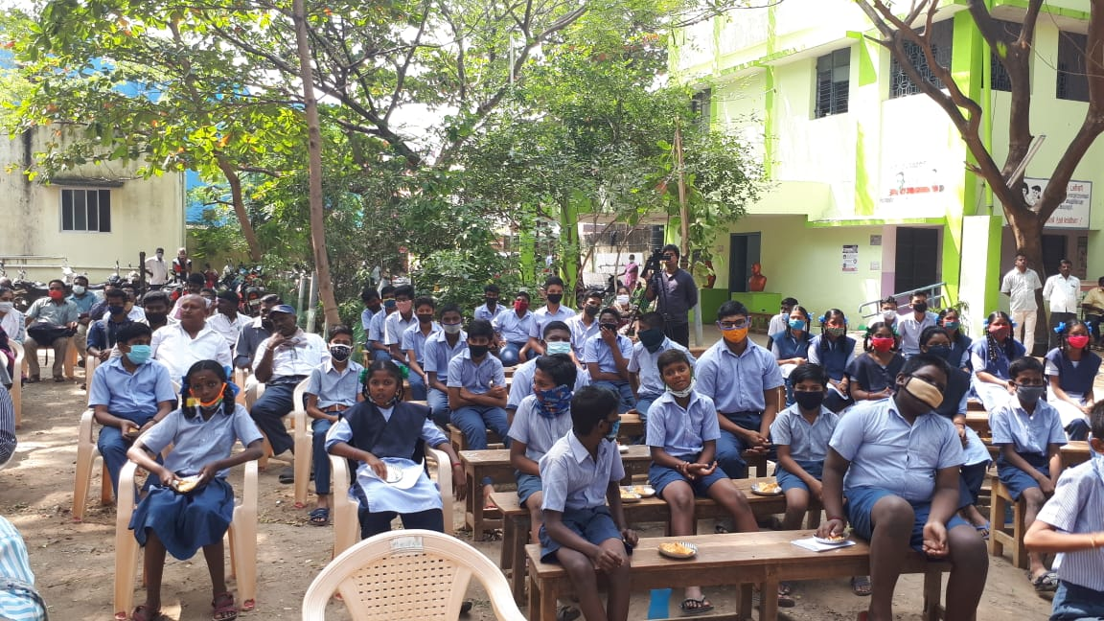

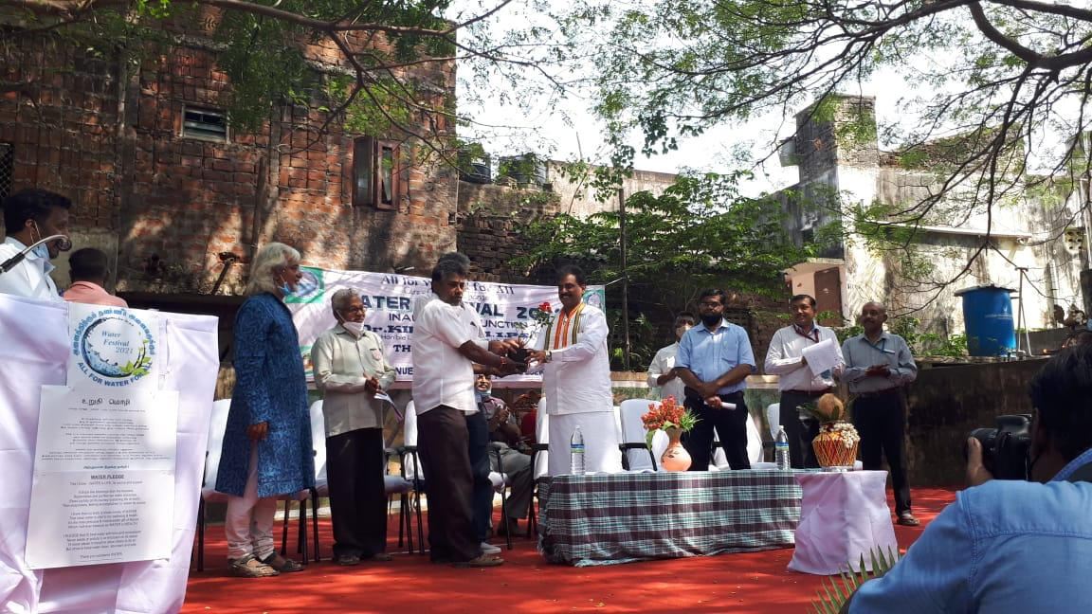

**10. Heritage Preservation Award:**

On 21th of February, the closing ceremony of Pondicherry Heritage festival happened at French Institution of Pondicherry. The PHF Organizer gave the welcome speech and were thanked, as well as volunteers for this festival.

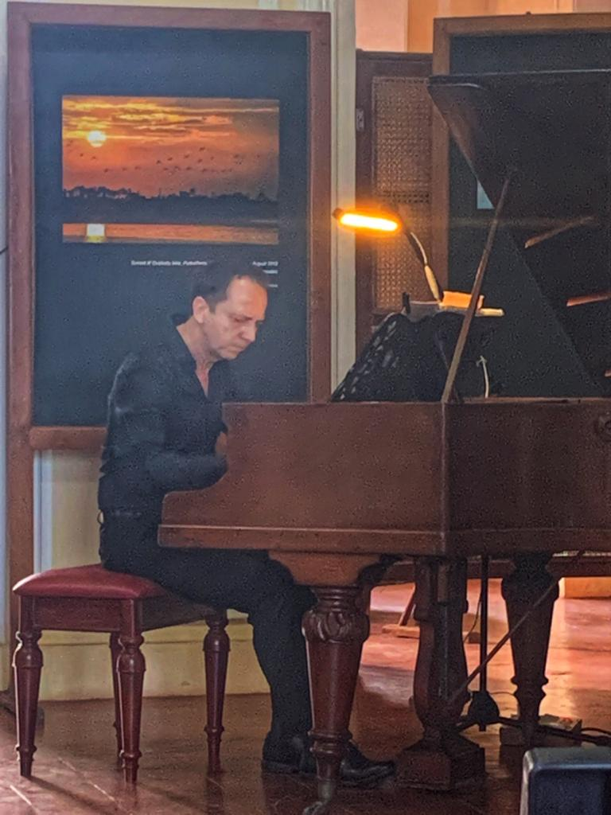

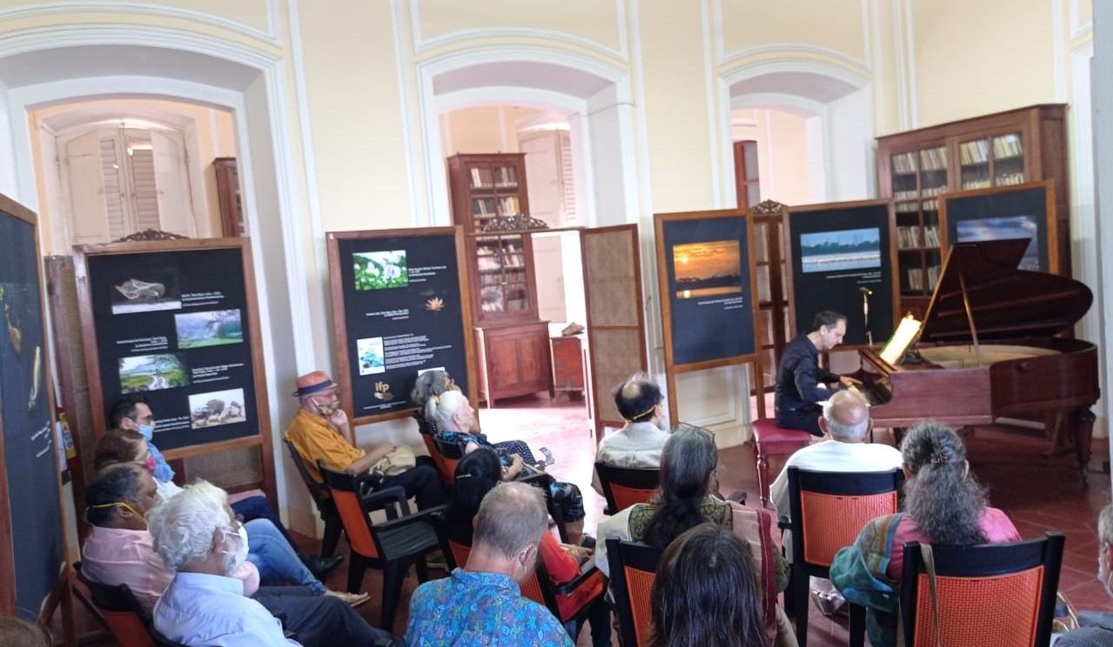

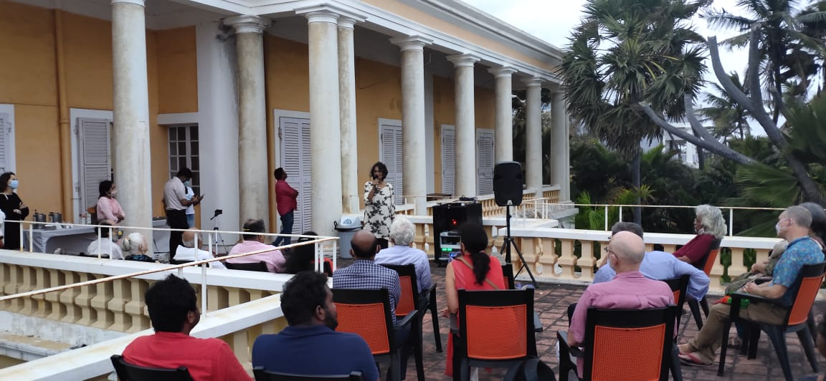

**Speech by Organisers of PHF**

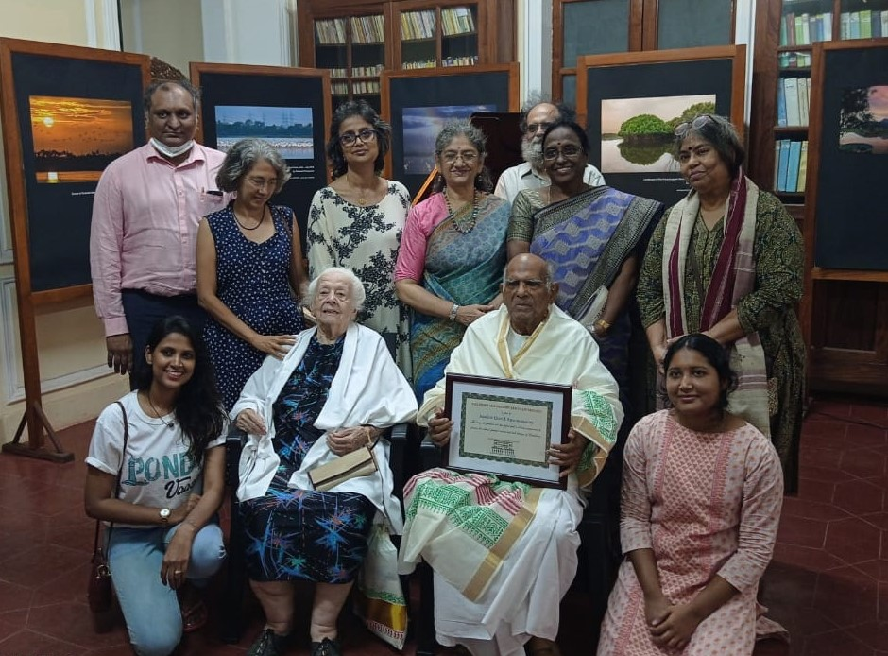



The organizers of the Pondicherry Heritage Festival 2021 would like to acknowledge, with gratitude all those who were involved in making the festival an

Immense success.